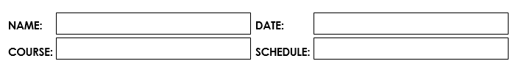

May 16, 2023

Abenes, Enrico O.

1: 30 pm – 5: 20 pm MT

CC1-INTL1

**Activity Number: 2**

**Activity Type:** Laboratory Activity

**TITLE: Identifiers and Variables**

**INSTRUCTIONS:**

1. Make sure you have your own individual account/monitor.

2. Always save your work and log off when not using the computer.

3. By now you should have been familiarized with using your text editor/net beans.

4. By now you should know how to create, save, compile, execute, and debug programs in Java.

**DURATION:** One to two Meetings

**HANDS-ON:**

1. Log on using your own individual account. Use your own username and

password.

2. Open your text editor/NetBeans.

3. Open your project folder CC1 INTL

4. Make a class name entitled IdentifiersAndVariables and save it.

*For those using online java programming you can still do that.

_____________________________________________________________________________

1. Write your next Java program:
   1. Write your next program by copying the source code shown below to your text editor.

/* Programmed by: <write your name here> Title: DataTypes.Java

Program Date: <write the date today here> */

public class DataTypes{

public static void main (String[] args){ char c = ‘C’;

int i = 97; double d = 0.00; byte b = 0;

System.out.println(“c = “ + c); System.out.println(“i = “ + i); System.out.println(“d = “ + d); System.out.println(“b = “ + b);

}

}

1. Save your program.

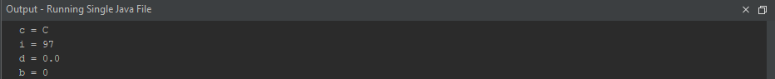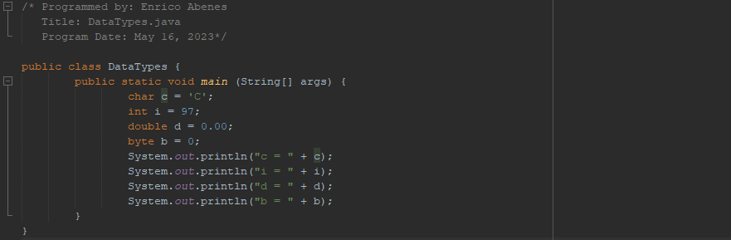Compile and Execute. What would be displayed as an output?

1. Modify the main() block and insert these statements before the

System.out.println() statements.

i = c; d = c;

1. Save, Compile, and Execute the program.
   1. 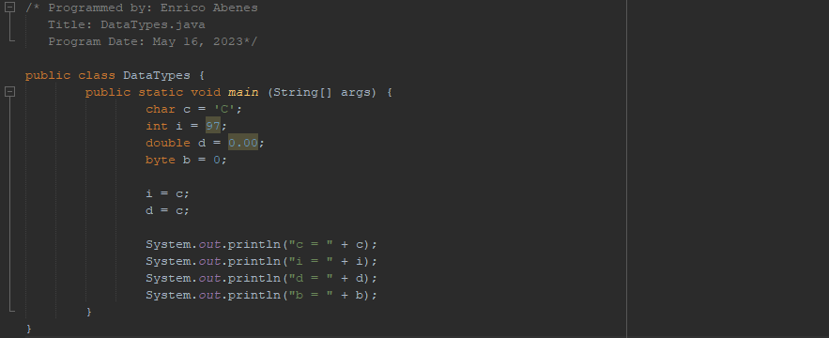What would be displayed as an output?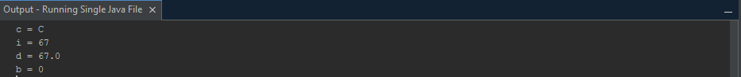
   2. Explain why the output is displayed as it is?

Because we did not alter the data types "int" and "double" into "char," it is to be expected

that the capitalized letter C will appear instead of the Unicode of "C," which is 67. We

modify it so that whatever appears in variable c will likewise appear in variables I and d.

1. Modify the main( ) block by deleting what you inserted in number 6 and inserting this statement in its place.

b=i;

1. Save and Compile the program.

Did it generate any error? Yes What is the description on the error?

DataTypes.java:12: error: incompatible types: possible lossy conversion from int to byte

b = i;

1. Modify the program again and instead of b = i, change it to i = b.
2. Save and Compile the program.

Note that the program should not anymore reflect an error.

What is the reason why it generated an error when the statement read b = i

and no error was generated when the statement read i = b?

If we use the "b = i;" command, we will get an error since we are allocating a larger data type (int)

to a smaller data type (byte). Instead, if we use "i = b;" there will be no error because byte can be

implicitly translated to int. Because the byte data type is smaller than the int data type, there is no

information loss; Java does the widening conversion from byte to int automatically.

1. Modify the main() block and insert the statements below before the System.out.println() statements.

String s = ‘S’;

1. Save and compile the program.
   1. What error did it produce?

DataTypes.java:14: error: incompatible types: char cannot be converted to String

String s = 'S';

* 1. How would you re-write the statement so that the String declaration would not generate any error?

String s = “S”; (altering/ modifying the apostrophe into a quotation mark)

1. Modify the program so that it would display the following as the output.

Student Information Lastname: <Your Lastname> Firstname: <Your Firstname>

Middle Initial: <Your Middle Initial> Age: <Your Age>

Course: <Your Course> Year: <Your Year>

Note that the data regarding Lastname, Firstname, Middle Initial, Age, Course, and Year should be declared in a variable with the proper data type.

Copy the code on the box provided.

public class StudentInformation {

public static void main (String[] args) {

String Lastname = "Abenes";

String Firstname = "Enrico";

char MiddleInitial = 'O';

int Age = 22;

String Course = "Information Technology";

int Year = 1;

System.out.println("Student Information");

System.out.println("Lastname: " + Lastname);

System.out.println("Firstname: " + Firstname);

System.out.println("Middle Initial: " + MiddleInitial + ".");

System.out.println("Age: " + Age + " years old");

System.out.println("Course: " + Course);

System.out.println("Year: " + Year + "st Year");

}

}

**Rubrics:**

|  |  |  |
| --- | --- | --- |
| Code Context | The source code submitted covers all the items specified in the activity and satisfactorily meets all these requirements. It also uses the specific Java features specified in the activity. | 20 pts |
| Code Function | The source code submitted works completely with no errors and provides the expected output when running. | 20 pts |
| Code Syntax | The source code submitted has sound logic and follows the proper syntax for Java, with no unnecessarily complicated code. | 10 pts |
| **Total** | | **50 pts** |